**Common Issues when Setting Hadoop Project with Docker or VM**

# Unable to start Cloudera QuickStart on Virtual Box

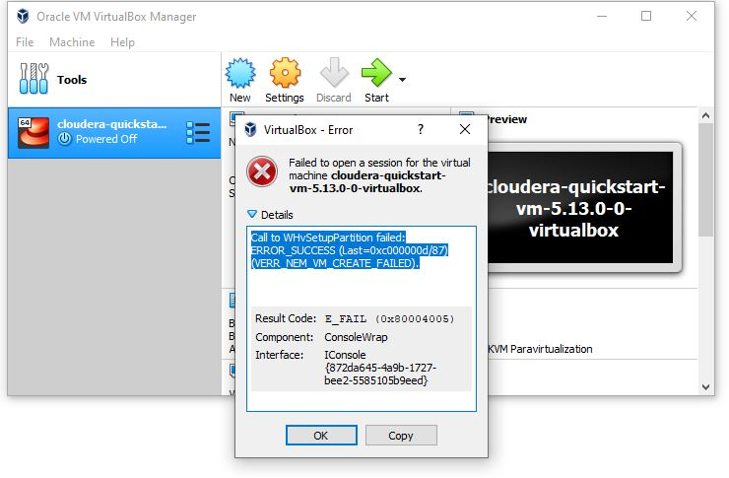

***Solution:***

<https://forums.virtualbox.org/viewtopic.php?f=6&t=92260>

RUN > CMD > bcdedit /set hypervisorlaunchtype off

then reboot host machine.

# Unable to export Java jar

Solution: Start new workspace

# Docker requires virtualization and data execution enabled in BIOS

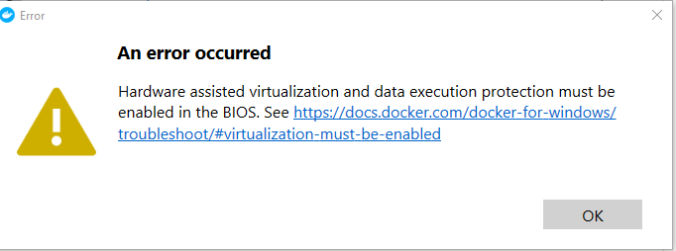

<https://dotnetthoughts.net/hardware-assisted-virtualization-and-data-execution-protection-must-be-enabled/>

RUN > CMD > bcdedit /set hypervisorlaunchtype auto

then reboot host machine.